ASSIGNMENT

# PROG 301: Advanced Programming with Python and Scripting

|  |  |
| --- | --- |
| PREPARED BY  Mehrin Farzana  ID: 2101013  Session: 2021-2022  Date: 26/11/2024 | SUPERVISED BY  Farzana Akter  Assistant Professor  Department of IRE, BDU |

|  |  |
| --- | --- |
| logo1 | BANGABANDHU SHEIKH MUJIBUR RAHMAN DIGITAL UNIVERSITY  (BDU) |
|  |  |

1. **List Questions**
2. 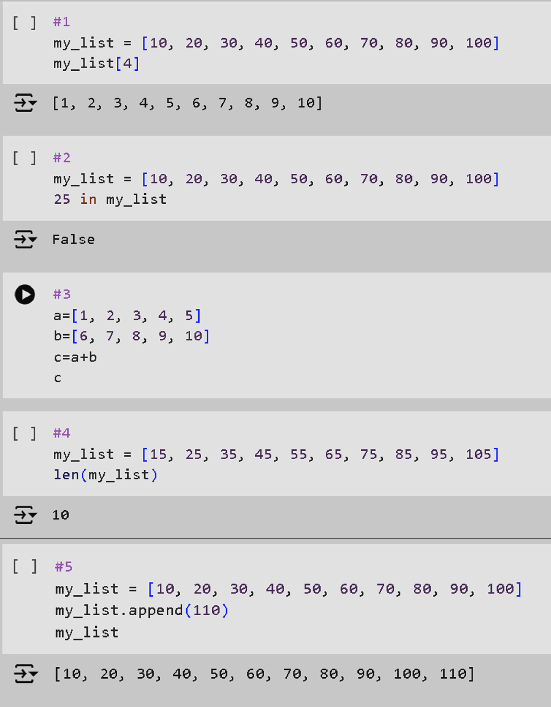

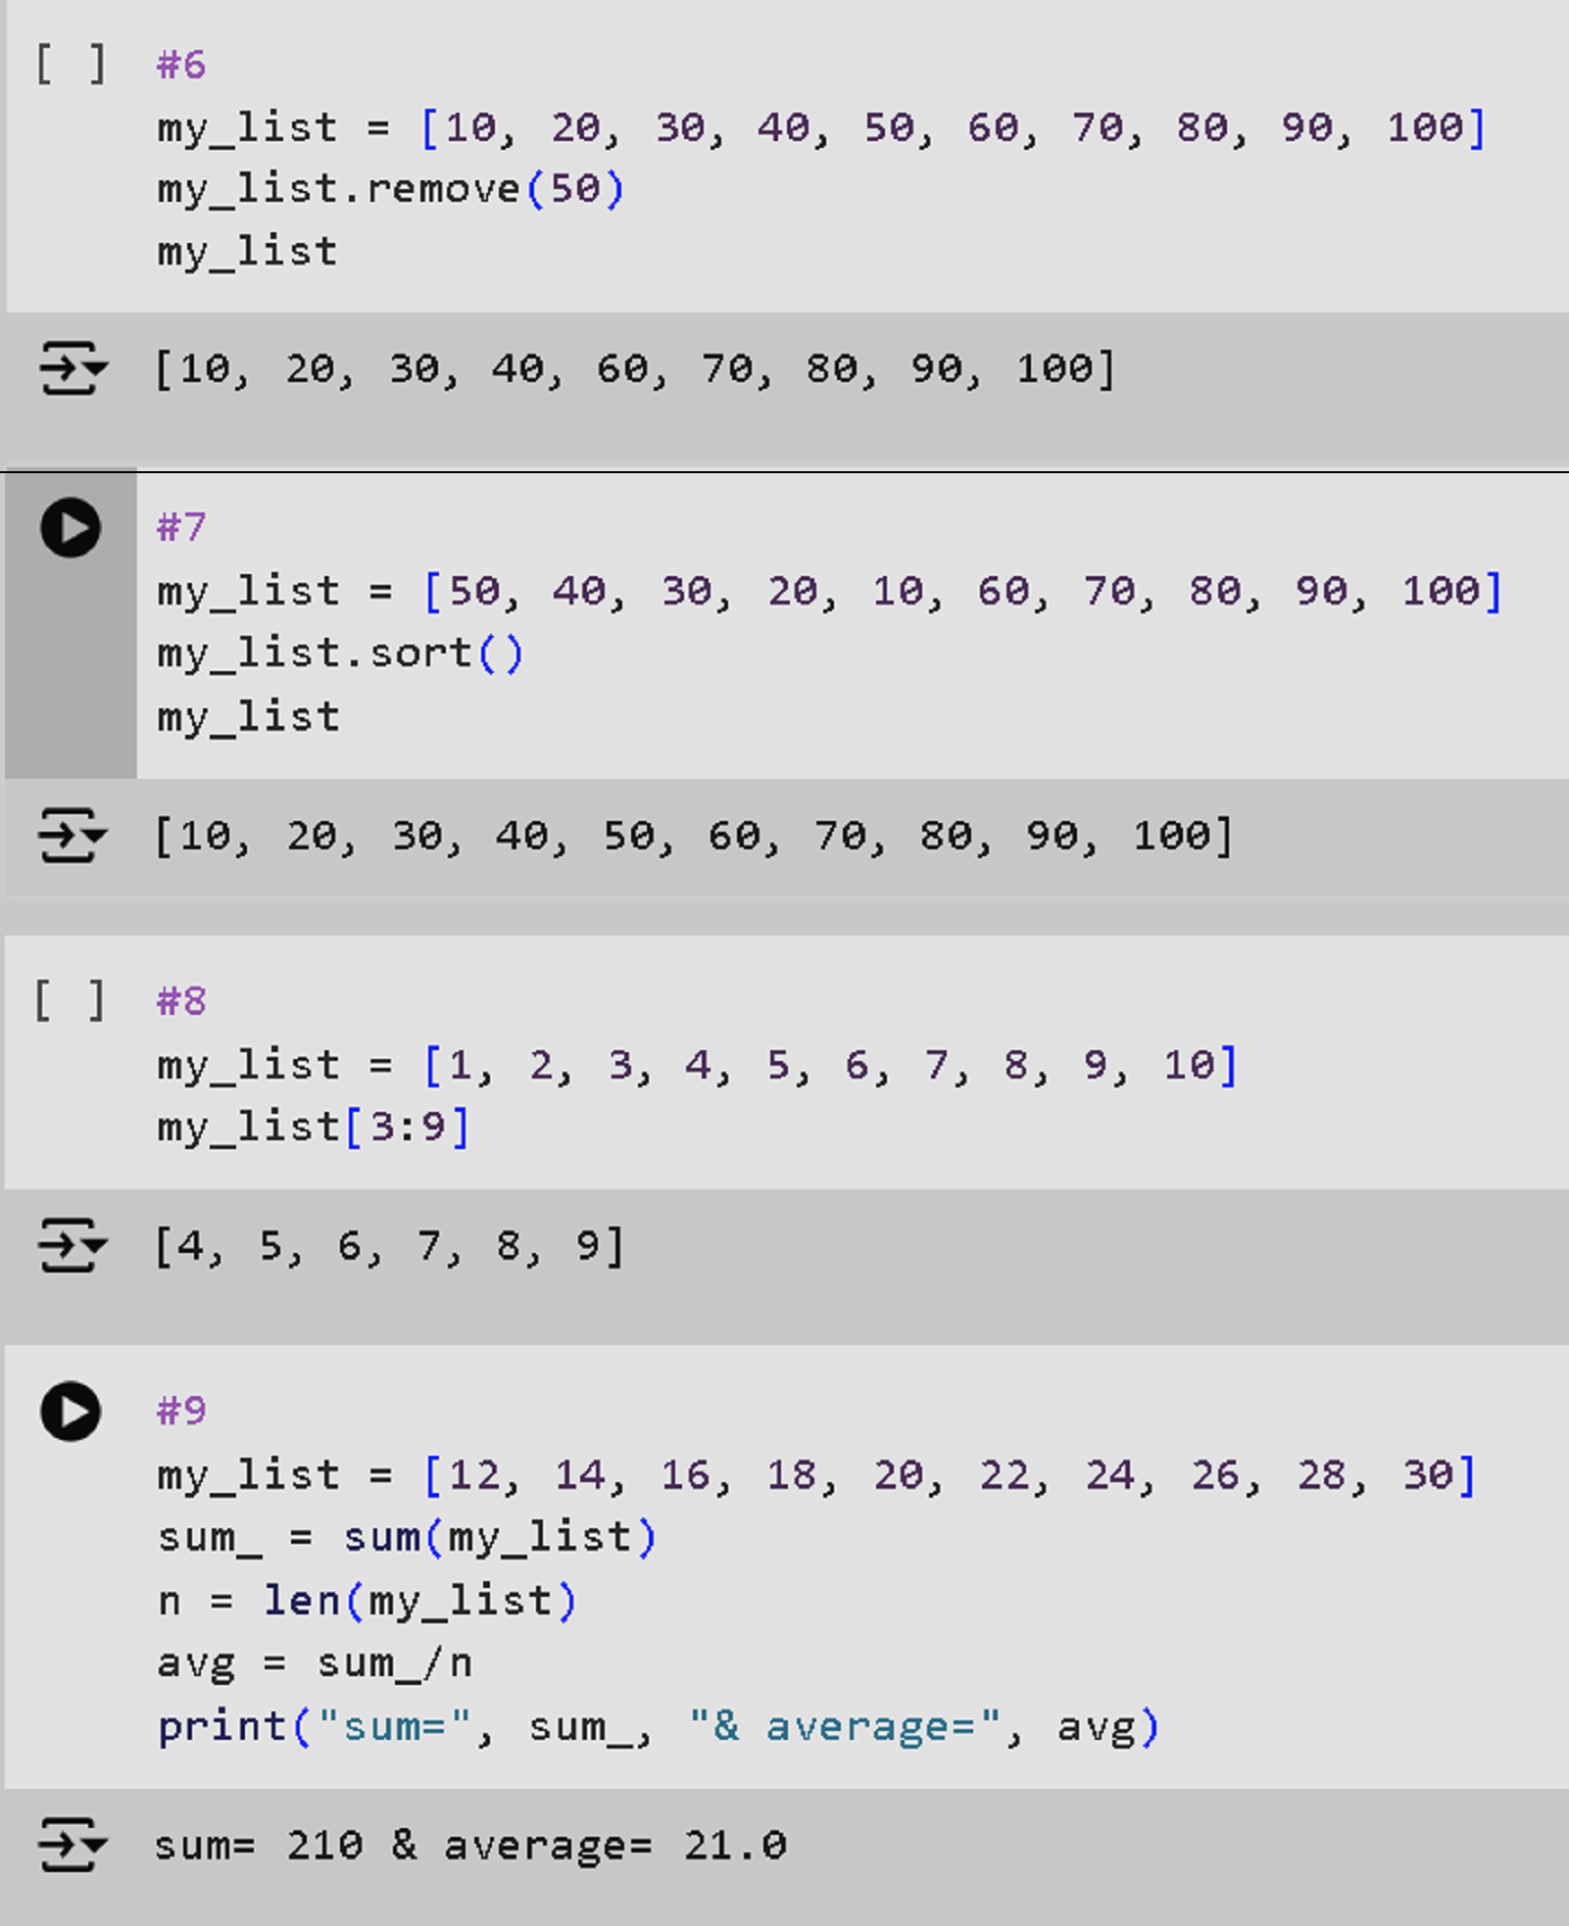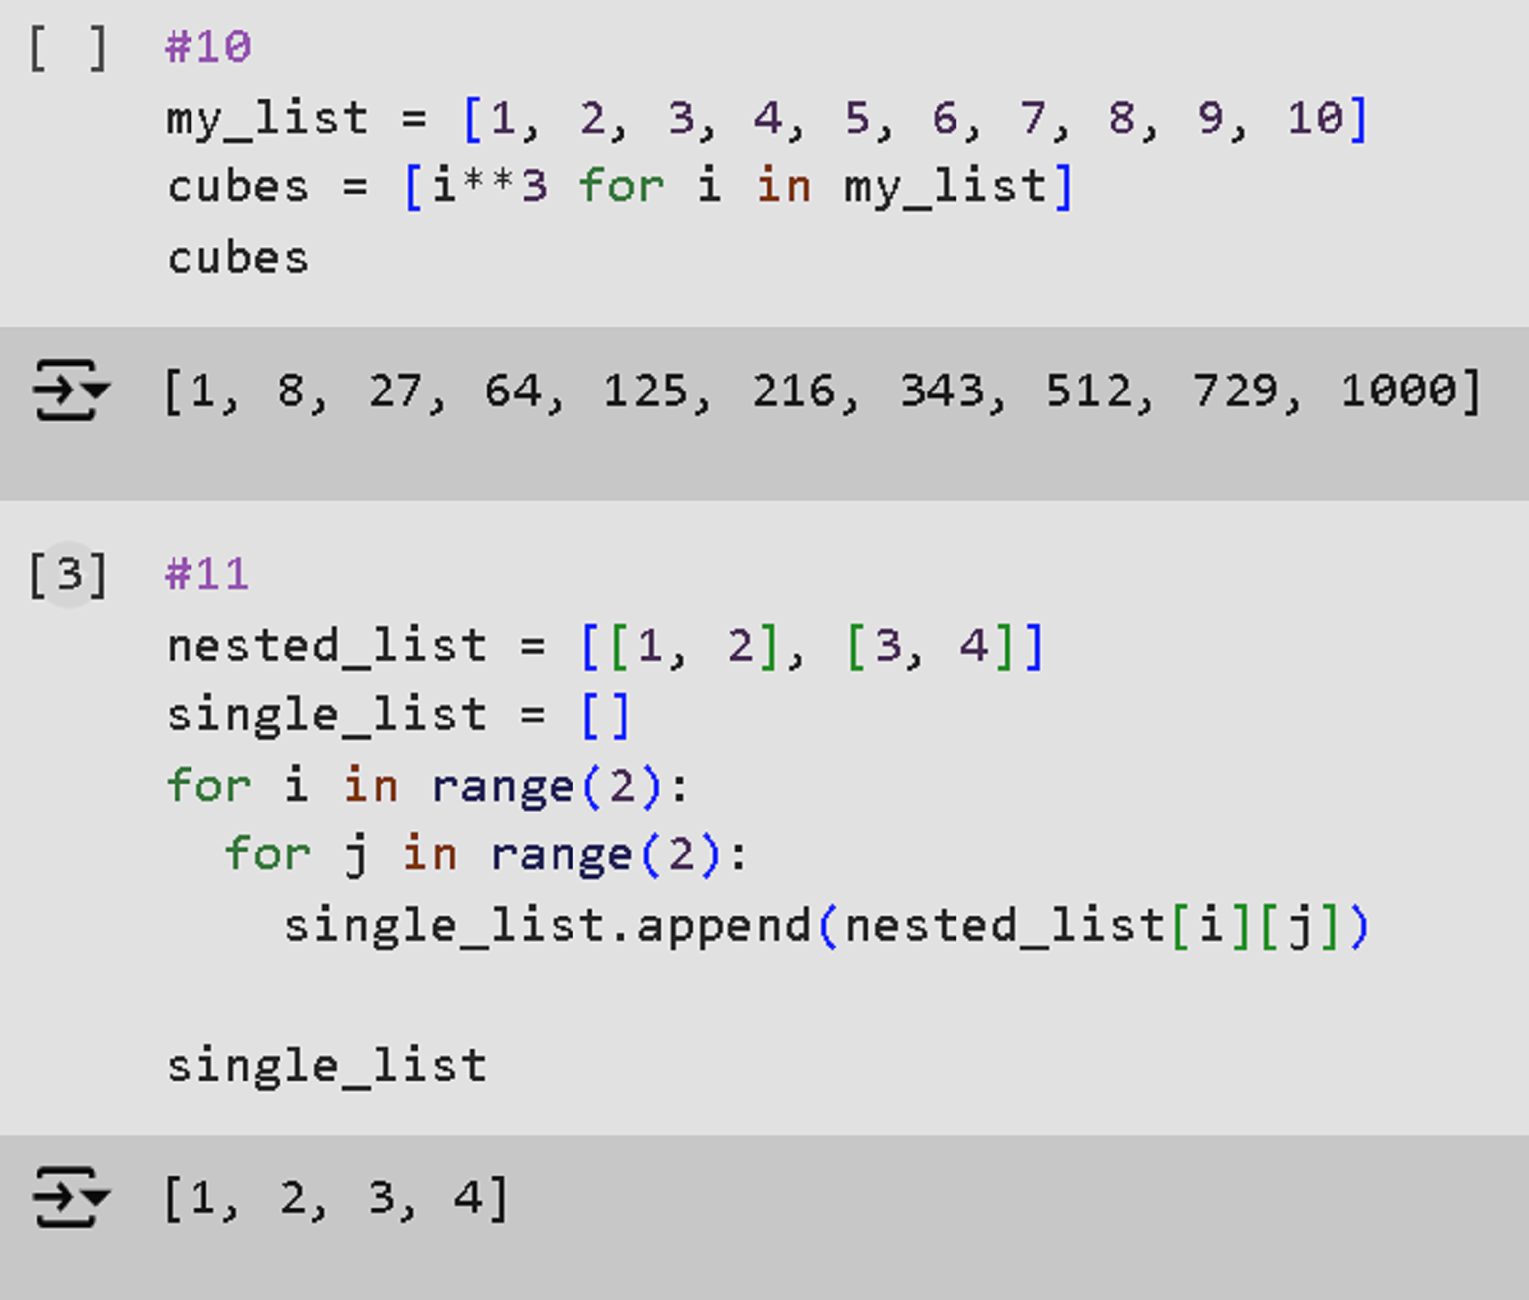

1. **Tuple Question:**

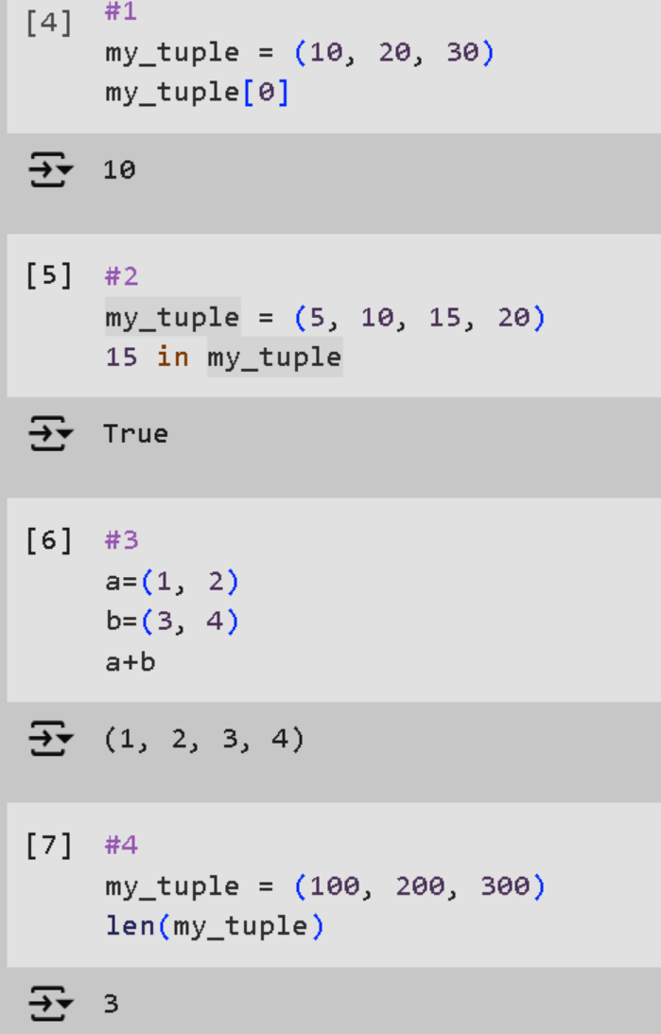

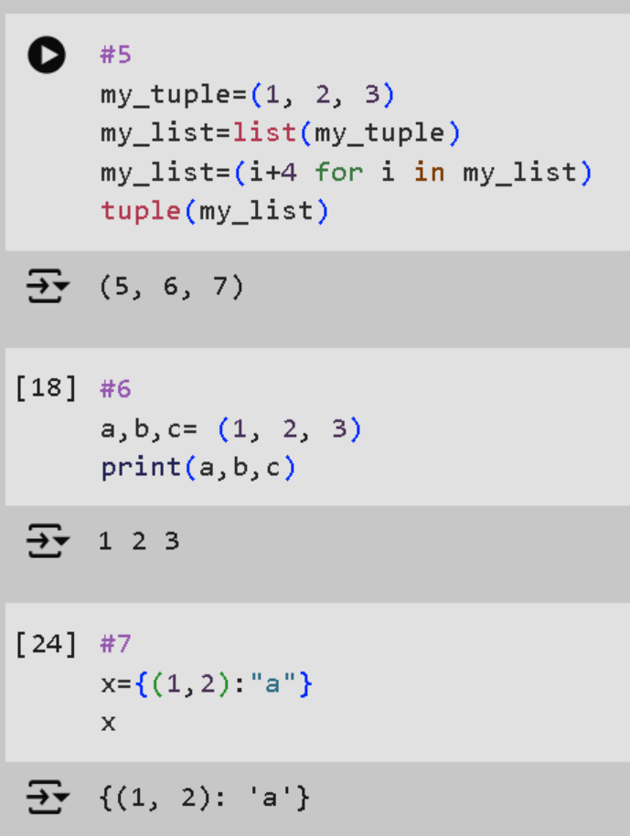

1. **Set Questions:**

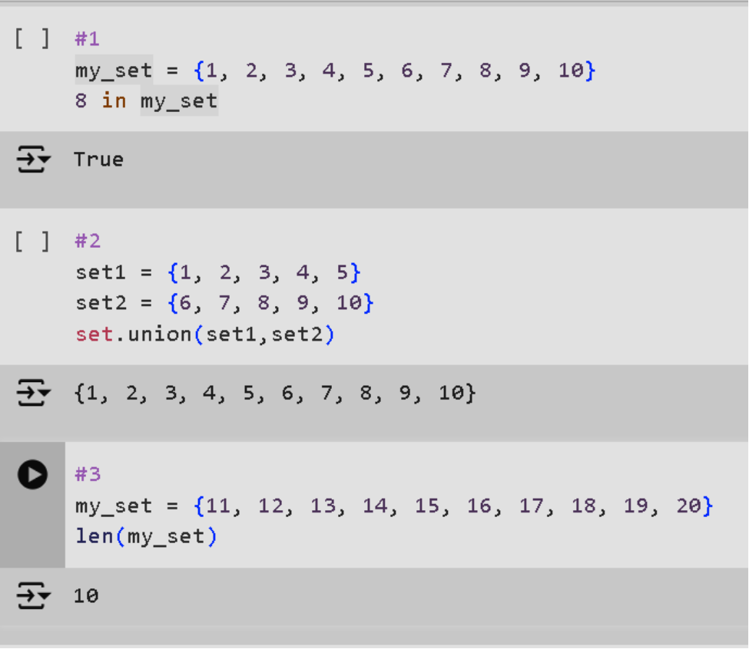

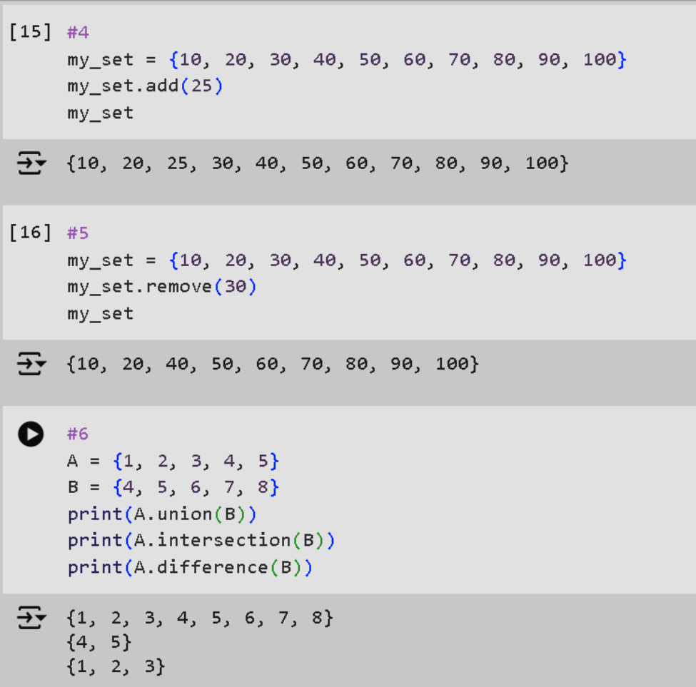

1. **Dictionary Questions:**

